
AstraQuantum Tech
Intermediate Linux & Cybersecurity Assignment
CMD Challenge + TryHackMe Practical Labs
Student Name | Muhammad Raza
Course | Linux & Cybersecurity Assignment - Intermediate
Programme | AstraQuantum Tech - Cybersecurity Summers
Submission Date | August 15, 2026
Practical Work | 20 CMD Challenge levels + 2 TryHackMe rooms

Table of Contents
1. Assignment Overview 3
2. Part A - CMD Challenge (20 Levels) 3
3. Part B - TryHackMe Labs 5
4. Lab 1 - Starting Out in Cyber Sec 5
5. Lab 2 - Inside a Computer System 6
6. Lab 3 - Intermediate THM Lab 7
7. Technical Understanding 7
8. Evidence Standards 8
9. Final Reflection 8
10. Final Submission Checklist 9

1. Assignment Overview
This assignment extends practical command-line skills and cybersecurity fundamentals through a larger CMD Challenge set and two completed TryHackMe rooms (a third room is reserved as a placeholder until the exact lab is assigned). All practical work below was completed independently and is reported using the structure provided.

2. Part A - CMD Challenge (20 Levels)
Website: cmdchallenge.com - Requirement: complete 20 CMD Challenge levels, recording the command or technique used, its purpose, and evidence of completion.
Level | Status | Command(s) / Technique | Purpose / Short Explanation
1 | Completed | echo "hello world" | Prints the string "hello world" directly to standard output.
2 | Completed | pwd | Displays the absolute path of the current working directory (print working directory).
3 | Completed | ls | Lists the names of all files and directories in the current directory.
4 | Completed | cat access.log | Concatenates and outputs the complete contents of access.log to the terminal.
5 | Completed | tail -n 5 access.log | Outputs only the last 5 lines of the specified log file (access.log).
6 | Completed | touch take-the-command-challenge | Uses the touch command to create a new, empty file with the specified name in the current directory.
7 | Completed | mkdir tmp && mkdir tmp/files | Creates the parent tmp directory and then the files subdirectory sequentially by chaining commands with the logical AND operator (&&).
8 | Completed | cp take-the-command-challenge tmp/files | Uses the cp command to copy the specified file into the target directory path.
9 | Completed | mv take-the-command-challenge tmp/files | Uses the mv command to move the specified file from the current directory into the target directory.
10 | Completed | ln -s tmp/files/take-the-command-challenge take-the-command-challenge | Uses the ln command with the -s flag to create a symbolic (soft) link pointing to the target file path.
11 | Completed | rm -rf ./* && rm -rf ./.* | Recursively and forcefully removes all standard files/directories (./*), then chains a second command to remove all hidden files/directories (./.*).
12 | Completed | find . -type f -name "*.doc" -exec rm -f {} + | Uses find to locate all files (-type f) ending in .doc recursively from the current directory (.), and executes the remove command (rm -f) on the results.
13 | Completed | grep "GET" access.log | Uses grep to search for and output only the lines containing the exact string "GET" within the access.log file.
14 | Completed | grep -l "500" * | Uses grep with the -l flag to search all files in the directory (*) and output only the filenames (not the matching lines themselves) that contain the string "500".
15 | Completed | ls -a access.log* | Uses the ls command with a wildcard (*) and the -a flag to list all files (including hidden ones) that start with the prefix "access.log".
16 | Completed | find . -type f -name "access.log*" -exec grep -h "500" {} + | Finds all files matching "access.log*" recursively and executes a grep search for "500", using the -h flag to suppress the filename in the output.
17 | Completed | find . -type f -name "access.log*" -exec grep -oE '([0-9]{1,3}\.){3}[0-9]{1,3}' {} + | Uses find to locate the target logs and executes grep with extended regular expressions (-E) to extract and output only (-o) the matched IP addresses.
18 | Completed | find . -type f | wc -l | Finds all files in the current directory tree and pipes the output to wc -l to count the total number of lines (which equates to the total number of files).
19 | Completed | sort access.log | Uses the sort command to output the contents of access.log in ascending alphanumeric order.
20 | Completed | grep "GET" access.log | wc -l | Uses grep to filter lines containing "GET" and pipes the result to wc -l to count the total number of matching lines.

Evidence Screenshots
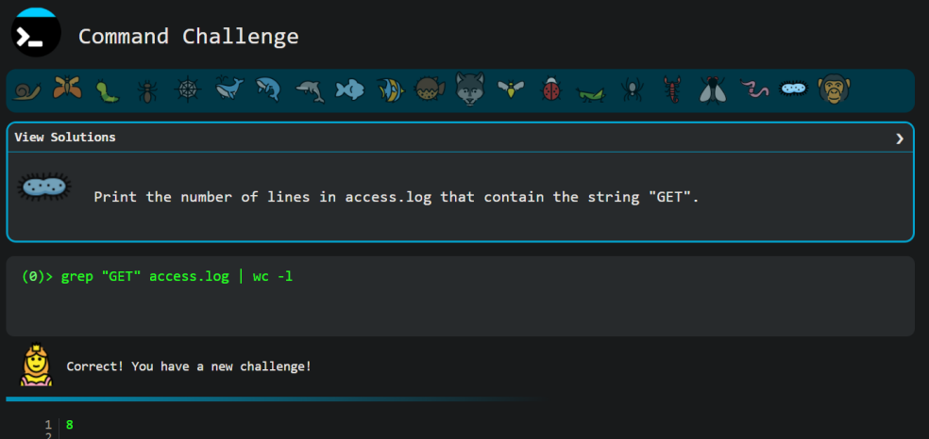
Level 1

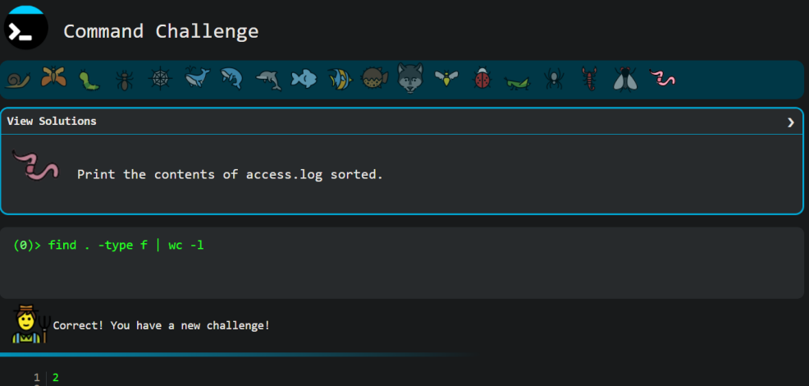
Level 2
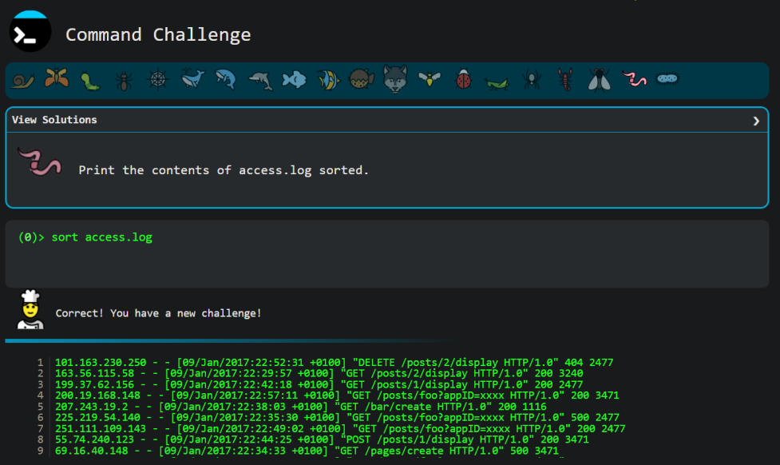
Level 3

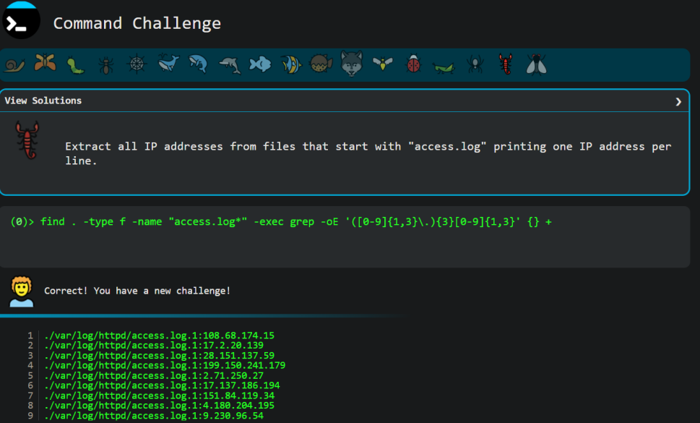
Level 4

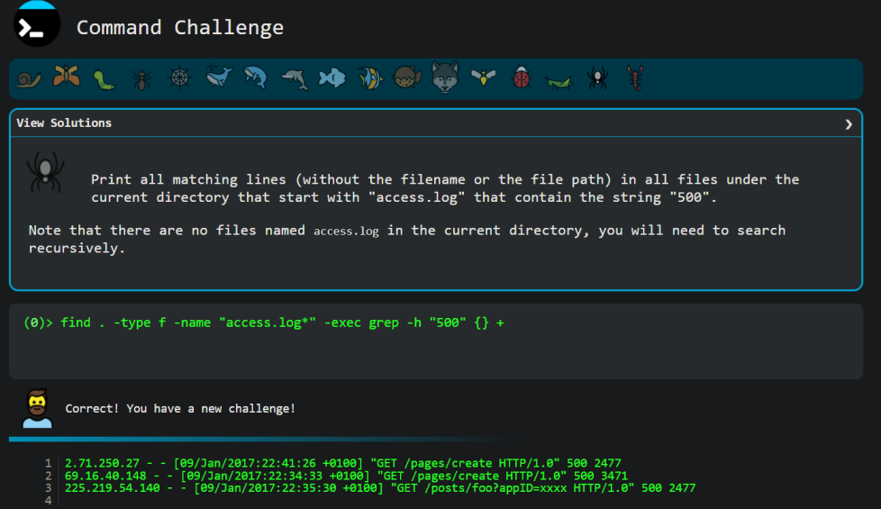
Level 5

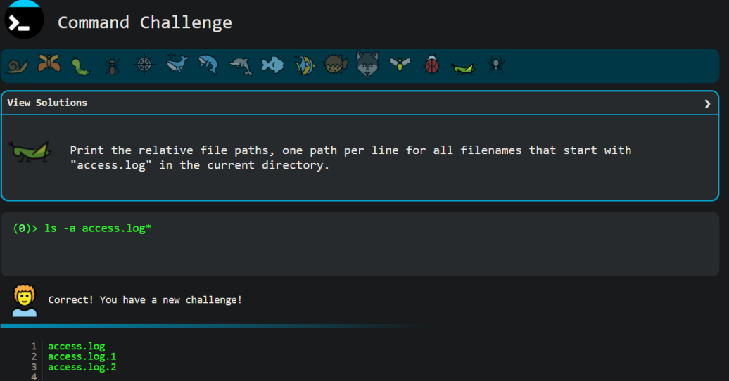
Level 6

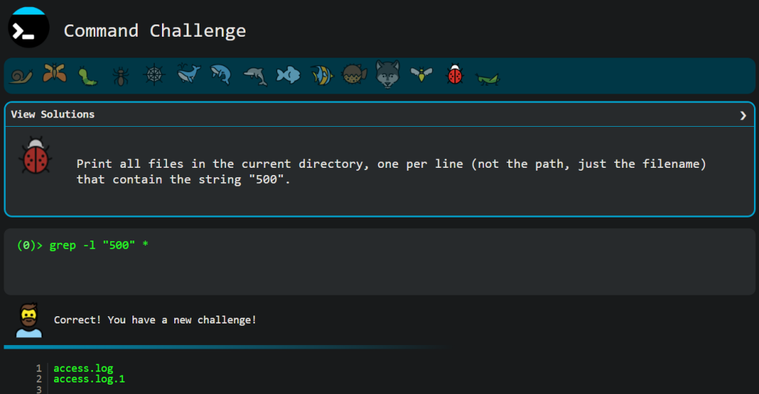
Level 7

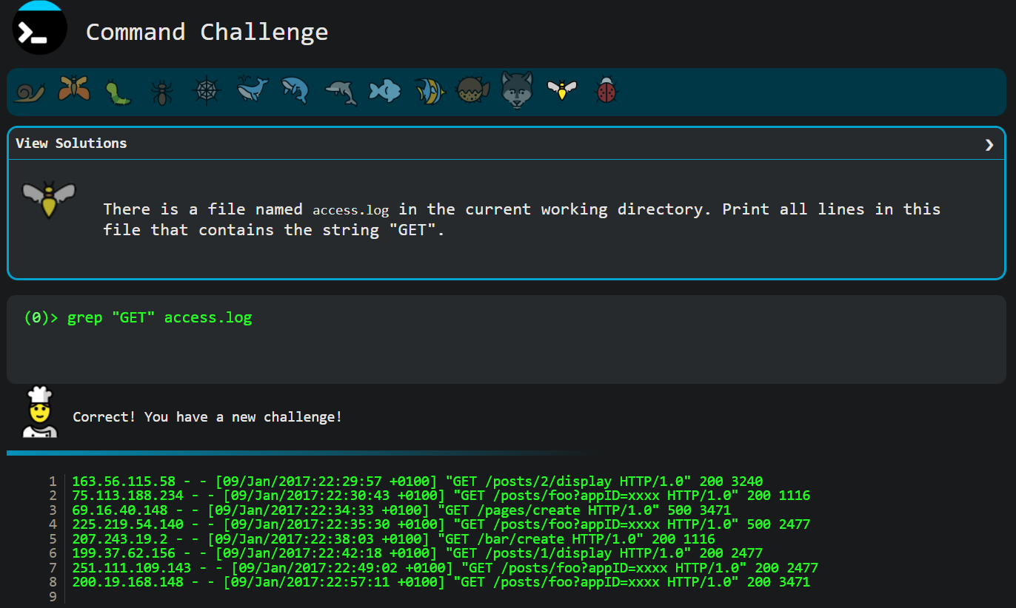
Level 8

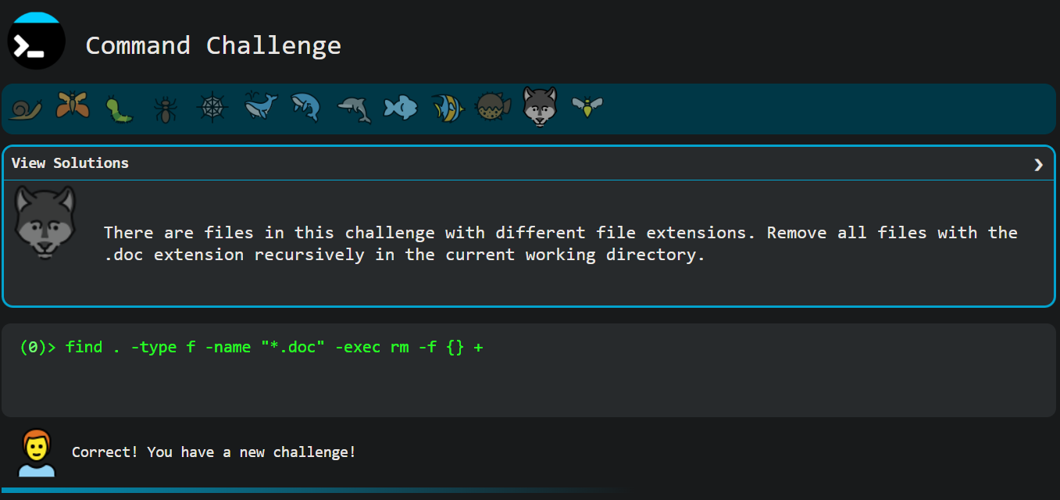
Level 9

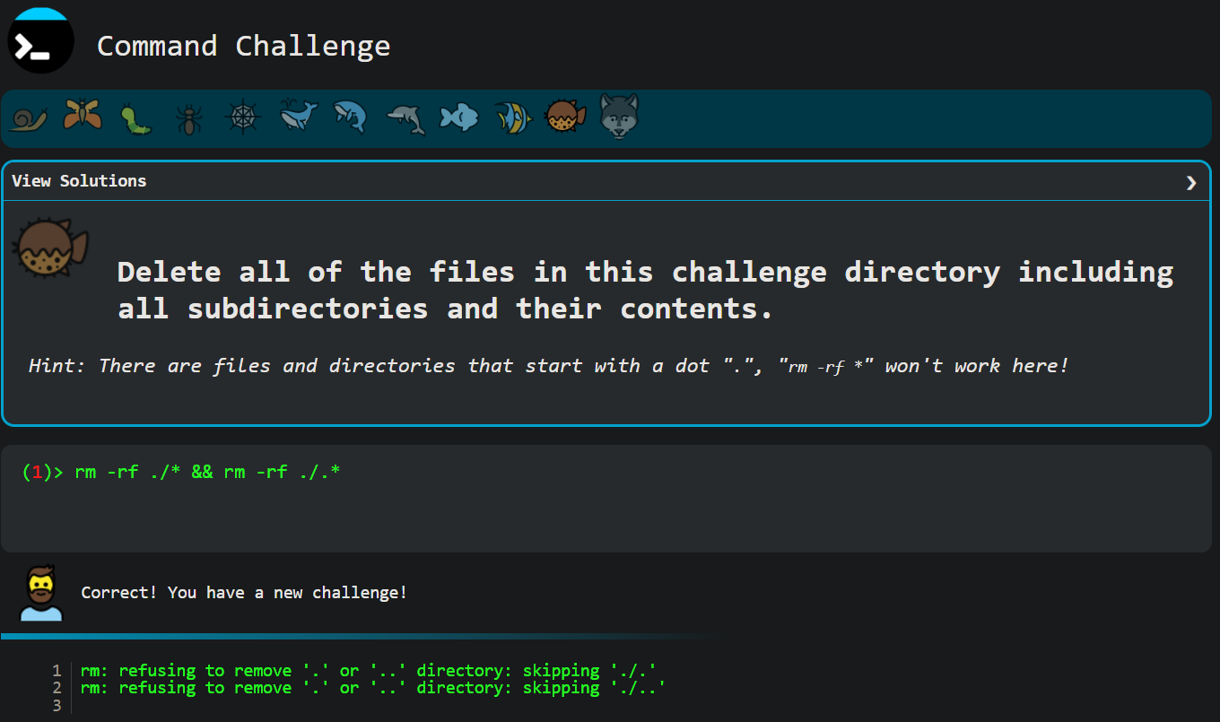
Level 10

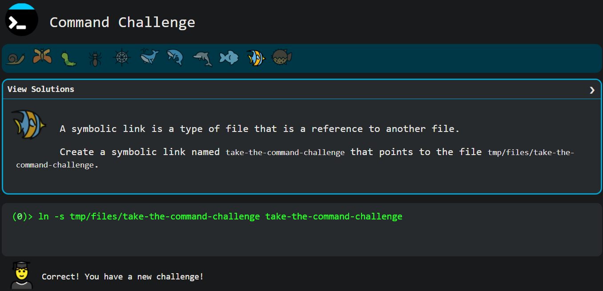
Level 11

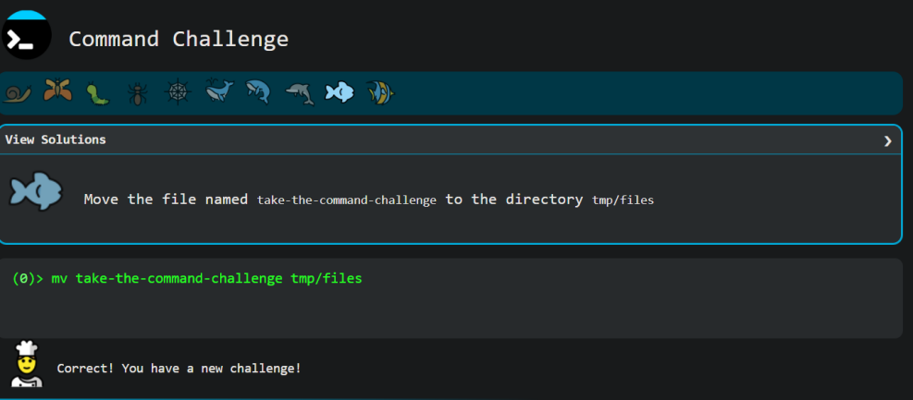
Level 12

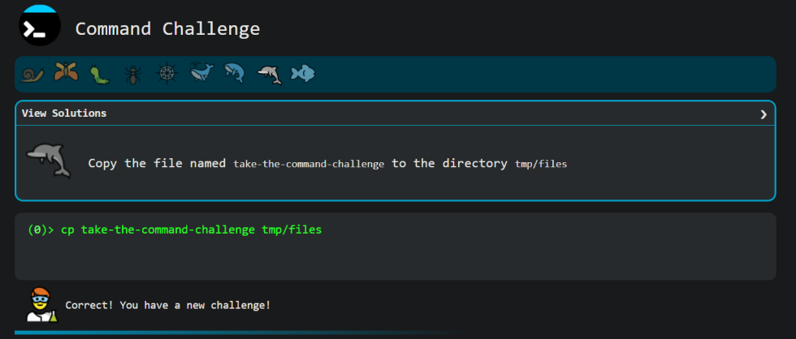
Level 13

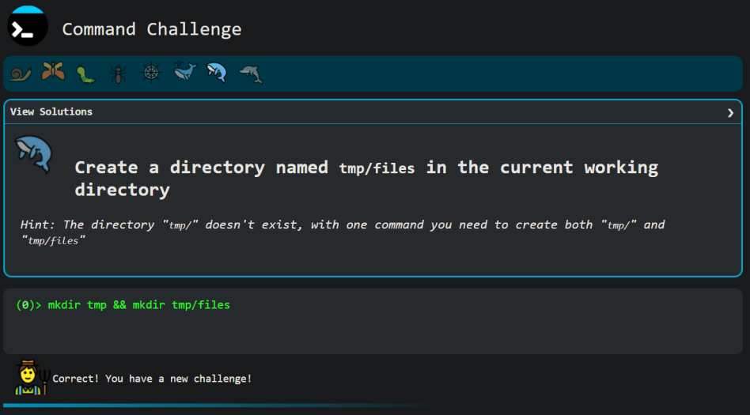
Level 14

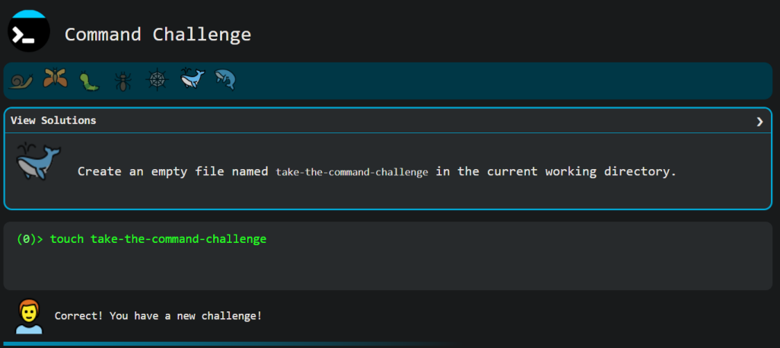
Level 15
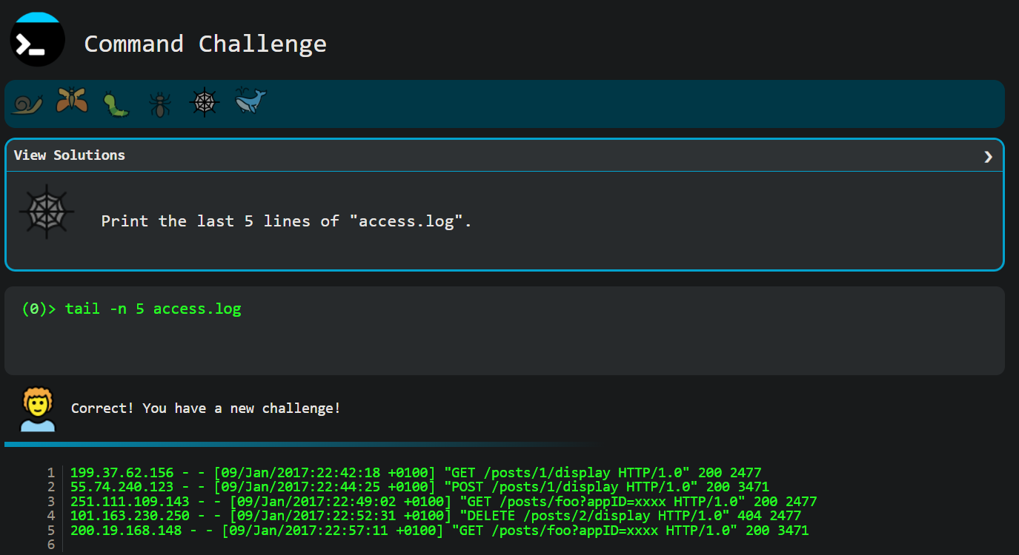
Level 16

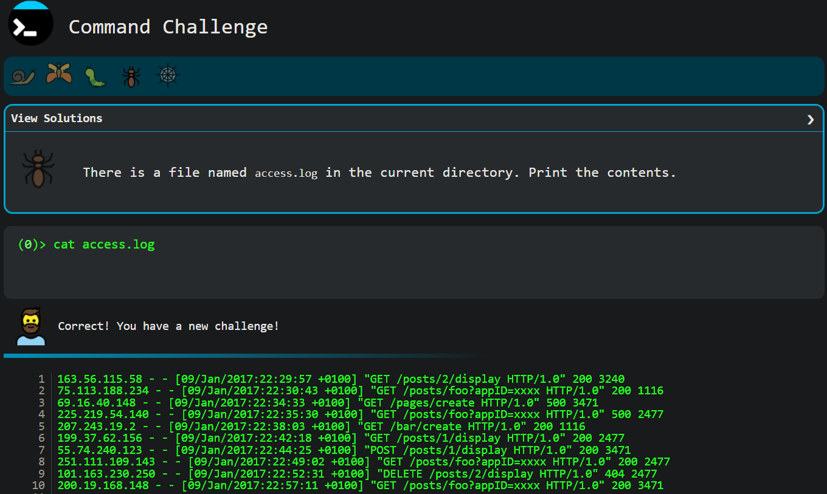
Level 17

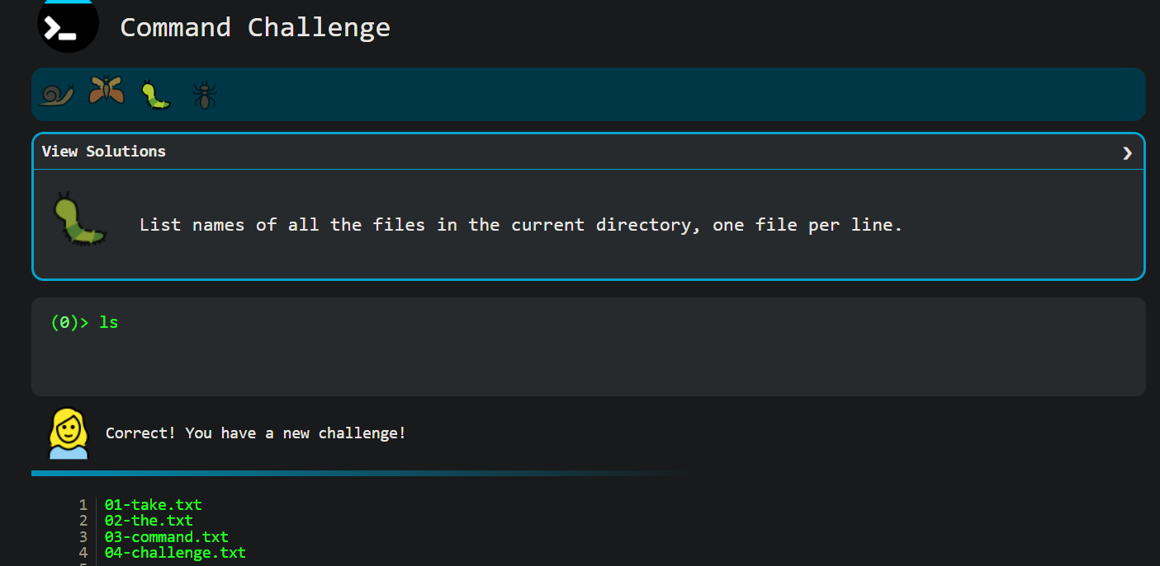
Level 18

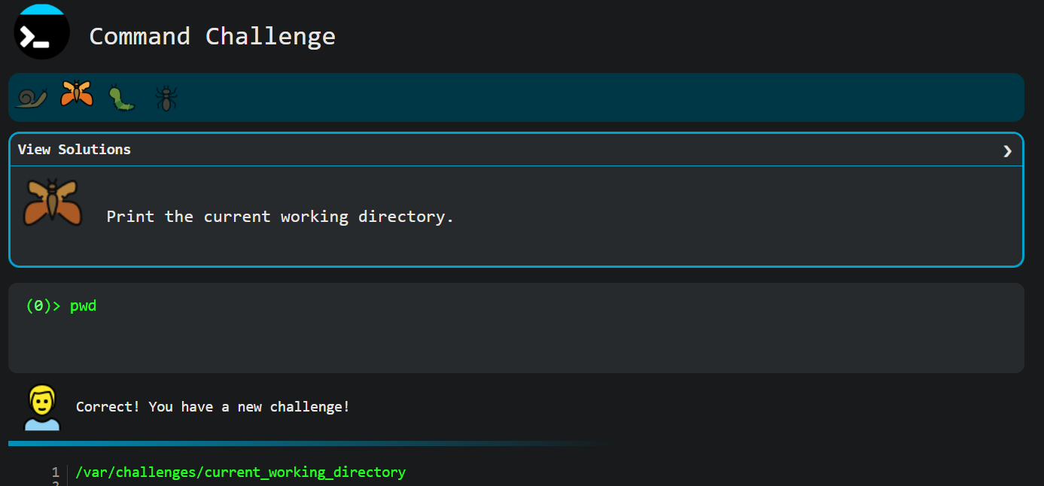
Level 19

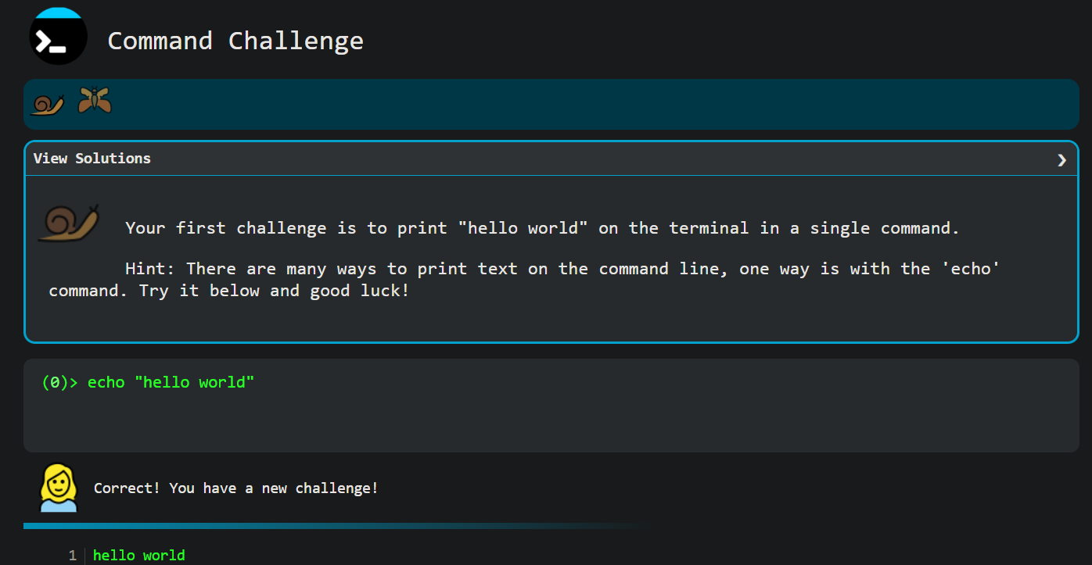
Level 20

3. Part B — TryHackMe Labs
Lab 1 - Starting Out in Cyber Sec: https://tryhackme.com/room/startingoutincybersec
Lab 2 - Inside a Computer System: https://tryhackme.com/room/insideacomputer
Lab 3 - Intermediate THM Lab: third lab to be inserted when the exact room is provided.

4. Lab 1 - Starting Out in Cyber Sec - Report
Completion Status
100% Completed.
Main Concepts
The fundamental divide in the cybersecurity industry between Offensive Security (actively finding vulnerabilities and misconfigurations) and Defensive Security (detecting, responding to, and stopping attacks).
Important Commands / Techniques
While this is a conceptual introductory room, it introduces high-level industry techniques such as monitoring systems for attacks using Splunk, analyzing memory to trace attacker actions using Volatility, and reverse-engineering or identifying strings in malicious applications.
Practical Tasks Completed
Reviewed the primary career tracks and the associated responsibilities for roles including Penetration Tester, Security Analyst, Incident Responder, and Malware Analyst.
Evidence / Screenshots
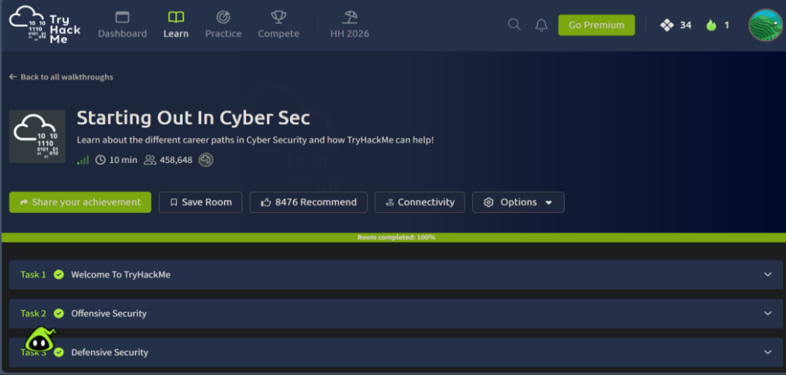
Reference: r 1 - Starting Out In Cyber Sec, room completed 100%
Key Learning Points
Success in either offensive or defensive security requires a broad, foundational understanding of underlying technologies, including web applications, networks, and cloud infrastructure (like AWS and Azure). Whether the goal is to write scripts to exploit a vulnerability or to analyze trace evidence left by an attacker, understanding how the core system operates is the essential first step.

5. Lab 2 - Inside a Computer System - Report
Completion Status
100% Completed.
Main Concepts
The basic physical and architectural components of a computer system, focusing on the motherboard and the systematic boot process.
Important Commands / Techniques
Identifying hardware architecture and tracing the sequential boot flow from hardware initialization to software loading.
Practical Tasks Completed
Explored the core components of the motherboard to understand how hardware interacts (Task 2). Traced the exact step-by-step process that occurs from pressing the physical power button to initiating the bootloader (Task 3).
Evidence / Screenshots
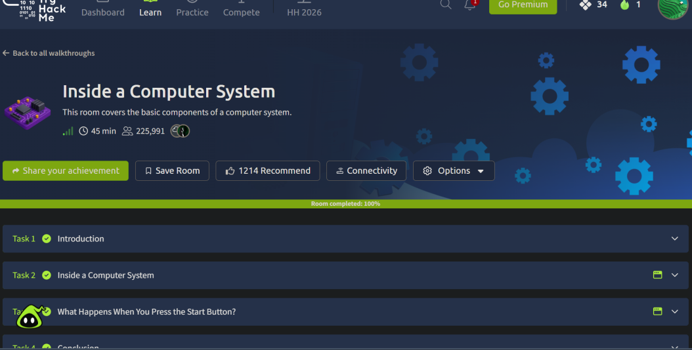
Reference: r 2 - Inside a Computer System, room completed 100%
Key Learning Points
Understanding hardware fundamentals and the boot sequence is crucial for cybersecurity. Knowing how a system transitions from a powered-off state to loading an operating system provides the necessary context for understanding boot-level vulnerabilities and how to secure physical infrastructure.
6. Lab 3 - Intermediate THM Lab - Report
This section is intentionally left as a placeholder until the exact third TryHackMe room is supplied. It will be completed and documented in the same format as Labs 1 and 2 (completion status, main concepts, important commands/techniques, practical tasks completed, evidence, and key learning points) once the room is assigned.

7. Technical Understanding
The following table explains six key commands and concepts encountered during the assignment, drawn from both the CMD Challenges and the TryHackMe labs, in my own words.
Command / Concept | Syntax / Definition | Purpose | Where Used
grep | grep [options] "pattern" [file]  A command-line utility used to search text for lines matching a specific pattern. | To filter large amounts of text or log files to find specific strings, such as error codes or IP addresses. | Used extensively in the CMD Challenge (e.g., finding "GET" or "500" errors in access.log).
find | find [path] [options]  A tool used to search for files and directories in a directory hierarchy based on specific conditions. | To locate files based on name, type, or size, and optionally execute commands (like rm or grep) directly on the results. | Used in the CMD Challenge to recursively locate files like .doc or files starting with access.log.
Piping (|) | command1 | command2  A technique that takes the standard output of the first command and passes it as standard input to the second command. | Allows for chaining multiple commands together to perform complex data processing in a single line. | Used in the CMD Challenge to pass the output of grep or find into wc -l to count the number of matching lines.
Symbolic Link | ln -s [target] [link_name]  A special type of file that serves as a reference or shortcut pointing to another file or directory. | Allows a file to be accessed from multiple locations in the file system without actually duplicating the file's contents. | Used in CMD Challenge Level 10 to create a shortcut to the take-the-command-challenge file.
Offensive vs. Defensive Security | Concept  The two main tracks in cybersecurity. Offensive security involves actively finding vulnerabilities (e.g., Penetration Tester). Defensive involves detecting and stopping them (e.g., Security Analyst). | Provides a framework for categorizing cybersecurity operations, methodologies, and career paths. | Explored in THM Lab 1: Starting Out in Cyber Sec.
Boot Sequence | Concept  The step-by-step initialization process a computer goes through from the moment the power button is pressed until the OS is loaded. | To initialize hardware components via the motherboard and securely load the bootloader and operating system. | Traced and analyzed during THM Lab 2: Inside a Computer System.

8. Evidence Standards
☑ Evidence is readable and directly demonstrates completion.
☑ Each screenshot corresponds to the relevant task or lab.
☑ Evidence was not fabricated, edited, or reused from another student.
☑ Unnecessary screenshots were avoided.
☑ No complete TryHackMe walkthroughs or spoilers were published.

9. Final Reflection
This assignment provided a highly practical bridge between theoretical cybersecurity concepts and hands-on system administration. Working through the TryHackMe labs clarified the distinct methodologies dividing offensive and defensive security, while detailing the hardware-level boot sequences that are critical for understanding low-level system vulnerabilities.
The CMD Challenge was particularly valuable for solidifying my command-line fluency. Navigating large datasets and parsing logs is a daily reality in Blue Team operations, so mastering commands like grep, find, and output redirection was incredibly relevant. Executing complex, chained commands using the pipe operator (|) to filter and count specific HTTP errors in the access.log file made the concepts click. It directly mirrors the type of active threat monitoring and log analysis required when engineering custom detection rules or aggregating events in a SIEM environment.
The most challenging aspect was Level 17 of the CMD Challenge, which required using extended regular expressions (-oE) with grep to extract specific IP addresses from the log files. Regular expressions require a strict syntax that can be unforgiving, but successfully executing the command demonstrated how powerful the terminal is for rapid, targeted data extraction.
Overall, the TryHackMe labs provided the foundational system architecture and security landscape, while the CMD Challenge provided the actual keystrokes needed to navigate those systems effectively. Moving forward, I plan to further practice writing complex regular expressions and building Bash scripts to automate the manual log parsing techniques I utilized throughout these levels.

10. Final Submission Checklist
☑ 20 CMD Challenge levels completed.
☑ CMD Challenge evidence included.
☑ THM Lab 1 completed and documented.
☑ THM Lab 2 completed and documented.
☐ THM Lab 3 completed and documented. (Pending - room not yet assigned)
☑ Technical understanding section completed.
☑ Final reflection completed.
☑ Student information completed.
☑ All screenshots are readable.
☑ Final document exported as one PDF.

